|  |  |  |
| --- | --- | --- |
|  |  |  |
| **Change text to: “Total Project Size KWAC”** | **Change Text to: “Total Current Power”** | **Change Text to: “Production, Performance %”** |
|  |  |  |

Please :

“Remove Decimal”

Change to:

Data Received

(Time Stamp)

Change to:

Current Power

(kW)

Please :

“Remove Decimal”

Please :

“Center”

Please :

“Center”

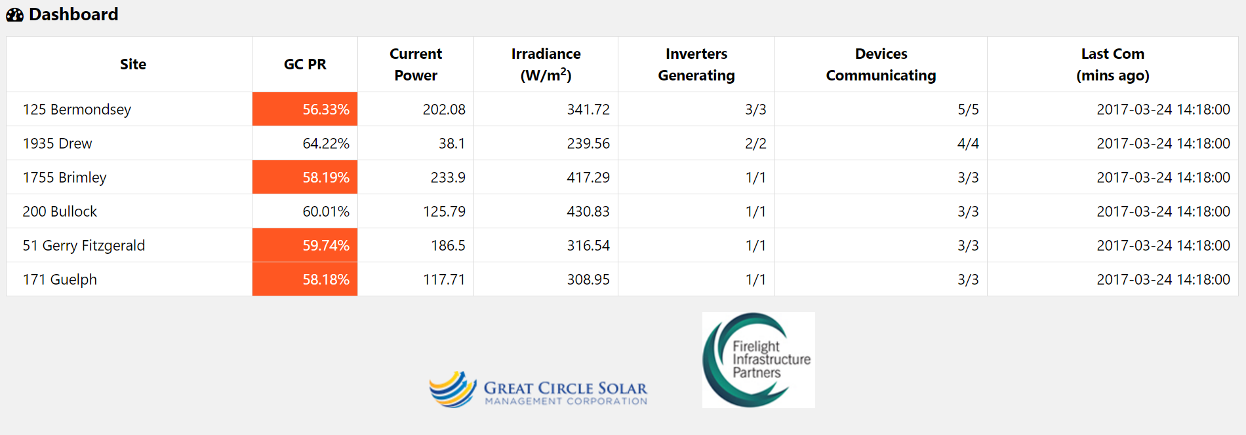

Please :

“Remove Decimal”

Please :

“Remove Picture/Logo”

Please :

“Remove Picture/Logo”

Add Column between GC PR and Current Power (KW):

“Project Size

(AC)”

Secondly can we make the background white instead of white?

Please see the attached:

Change to: GCS Dashboard with White Background



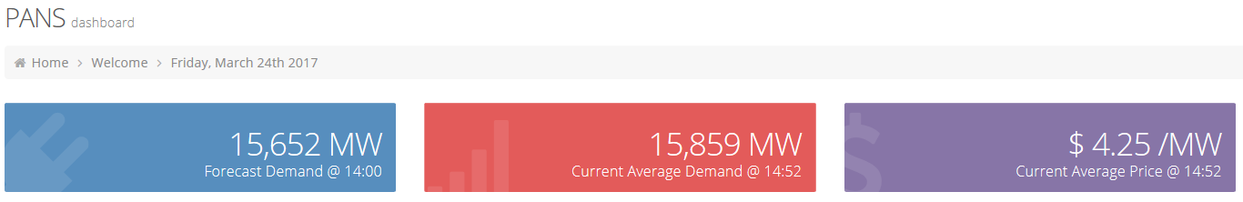

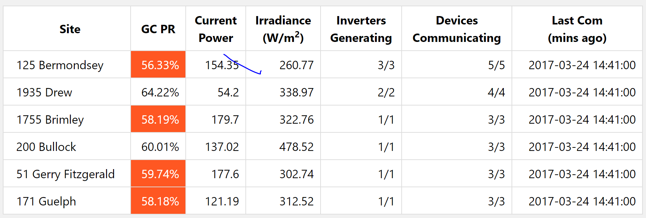

I want the dashboard to look similar to this with the date above. Please add combine this look with our comments.